**Data collection**

Measuring baPWV

**Quick summary //PWV**

**velocity is frequency* multiplied by wavelength.**

**Wavelength is 660nm oxygenated and 940nm deoxygenated blood. Av is 800nm.**

**800nm is converted to cm to by multiplying is by 0.0000001 or 1e-7**

**frequency is calculated by 120BPM = 2 hertz**

**convert Beats per minute (BPM) to frequency then multiply it by wavelength.**

**V=f*W**

**PWV1=(((BPM*2.0)/120.0)*(wavelength));**

**multiply PWV1 with *0.000000001 or *1e-7.0 to conv to cm/s**

**transit time if we know distance is 0.9 and PW(velocity) we can get time.**

**float distance=80.0;//distance in cm from baPWV or cfPWV**

**transit time=distance/PWV1;**

Device

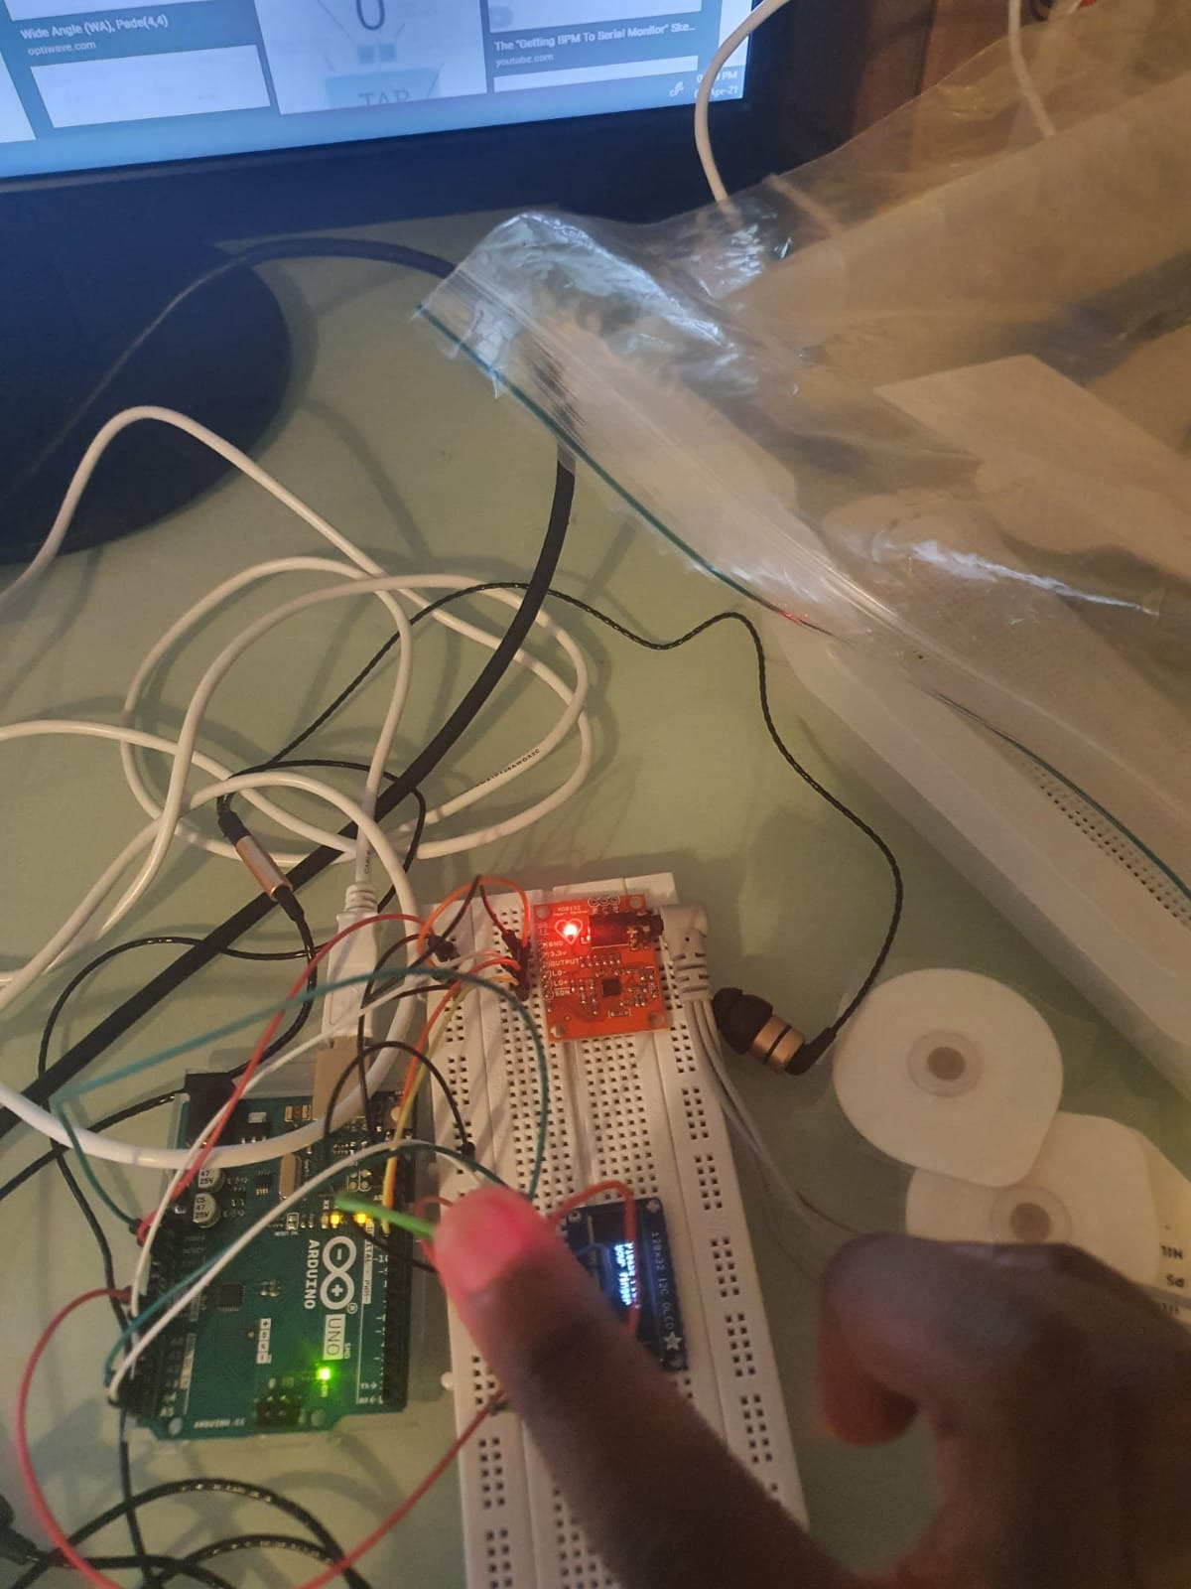

Pulse oximeter

This is a snippet of the code. It shows the PWV calculation implemented in the Pulse oximeter

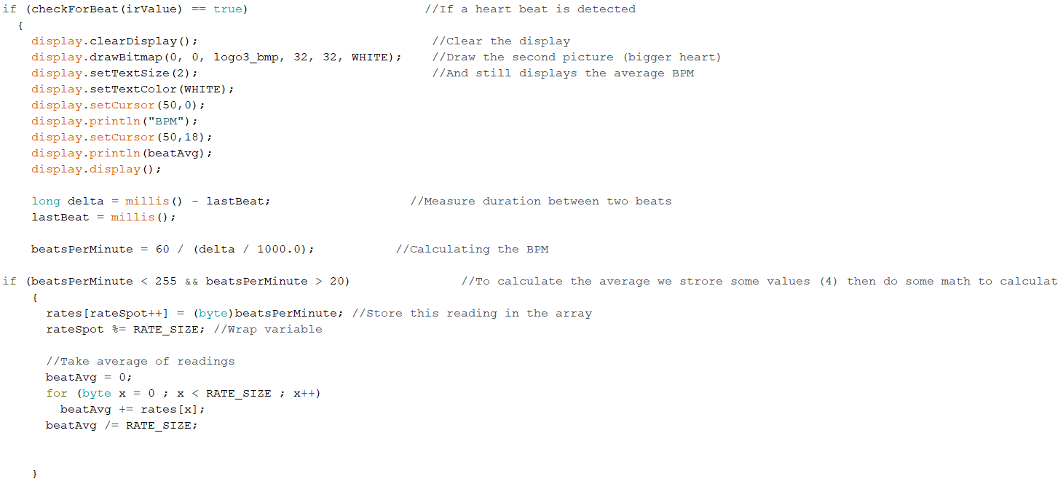

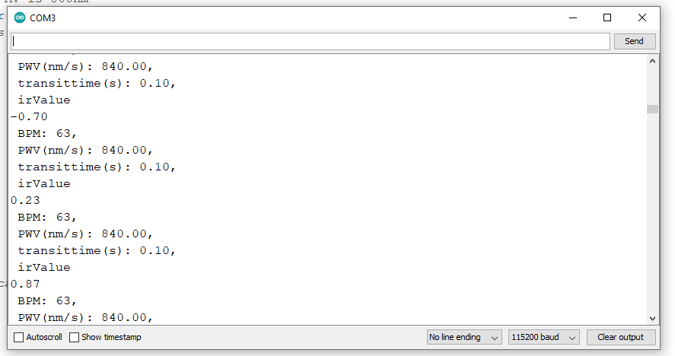



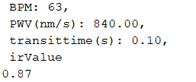

The PWV was taken at every second; it was converted from n/m into m/s.

Finger-tip PWV readings:

|  |  |  |  |  |  |
| --- | --- | --- | --- | --- | --- |
| **Student A** | | | **Student B** | | |
| Heart rate (bpm) | PWV (nm/s) | Transit Time (secs) | Heart rate (bpm) | PWV (nm/s) | Transit Time (secs) |
| 52 | 693.33 | 0.12 | 52 | 693.33 | 0.12 |
| 59 | 786.67 | 0.10 | 58 | 773.33 | 0.10 |
| 63 | 840.00 | 0.10 | 59 | 786.67 | 0.10 |
| 75 | 1000.00 | 0.08 | 75 | 1000.00 | 0.08 |

|  |  |
| --- | --- |
| **Mean PWV Student A B** nm/s | **Mean PWV Student B** nm/s |
| 3320 / 4 = 830 | 3253.33 / 4 = = 813.3325 |

|  |  |
| --- | --- |
| **Standard deviation PWV Student A** | **Standard deviation PWV Student B** |
| = 128.524 (3 sig fig) | = 131.089 (3 sig fig) |

The standard deviation value measures the dispersion of the observed reading from the mean.

Statistical comparison of results

The Shapiro–Wilk test was used to check if if the data was normally distributed

Bland–Altman plot was used to analyse the agreement between the two different PWV measurement techniques.

**Pearson Correlation test**

**Results**

As evident from the collected data, the results varied. This is due to various gender; arterial stiffness is proven to be higher in men (who are also typically hypertensive). There are also differences in regard to the amount of pressure that was allocated from the finger-tip onto the bio-sensor. As this is subjective to the subject, the pressure will affect the PWV reading as well as the chances of motion artefacts, as this will also determine the concentration of ambient light present during the PPG process.

The results also varied from the presence of sweating. As student A has the higher tendency of profuse sweating, the bio-sensor has detected this obstruction. This was clear during their reading, as the measurements took time to process the values after several repeats.

Although the subjects varied in age, the obtained data is still similar in values by a standard deviation of . This proves the efficacy of the device, showing that it is versatile, regardless of the subject’s stage of arterial aging.

Accuracy in testing:

As indicated in the protocol, measurements were taken to ensure that the subject endures unbiased etiquette so that maximal effort was taken for the readings to be close to precise. It was ensured that the subjects did not consume caffeine, tobacco, alcohol, or other drugs prior to testing, so that their heart rate is not influenced in any way.

The subject’s sitting position during the testing was also unaffected; the same chair was used by both subjects, so that their heart rate was not changed

Furthermore, the subjects had the same location of their index finger, placed on the PPG bio-sensor. The radial pulse is typically taken at the index finger or the 3rd finger, so the index finger was opted in this instance.

PPG Data (conversion nm/s to m/s)

Subject A pulse oximeter

R1

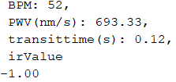

**PWV in m/s is 693.33 * 10^-9**

R2

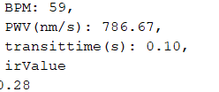

**PWV in m/s is 786.67 * 10^-9**

R3



**PWV in m/s is 840 * 10^-9**

R4

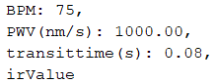

**PWV in m/s is 1000.00 * 10^-9**

Subject B pulse oximeter

R1

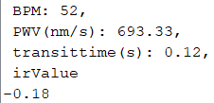

**PWV in m/s is 693.33 * 10^-9**

R2

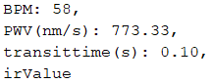

**PWV in m/s is 773.33 * 10^-9**

R3

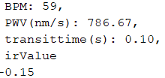

**PWV in m/s is 786.67 * 10^-9**

R4

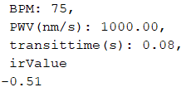

**PWV in m/s is 1000.00 * 10^-9**

ECG:

Calculation snippet

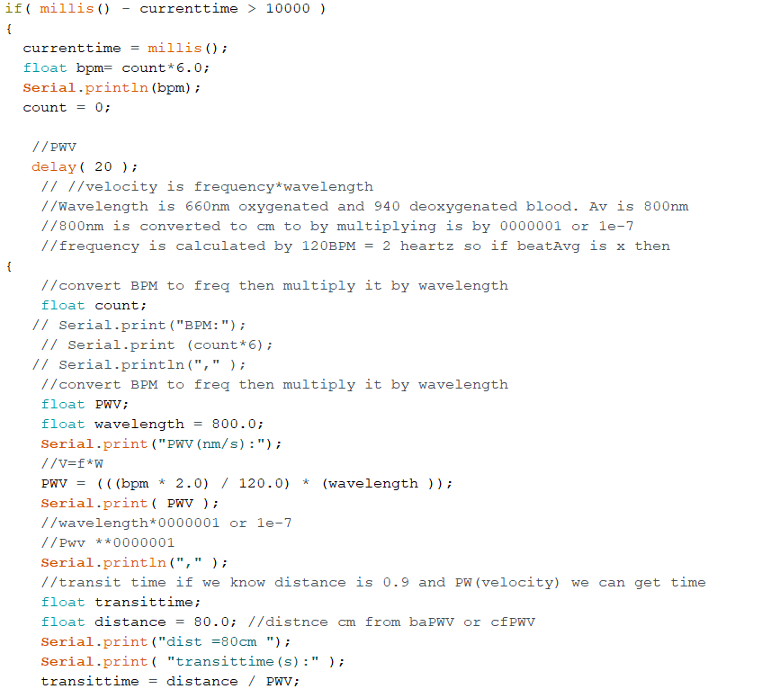

showing heart rate (bpm)

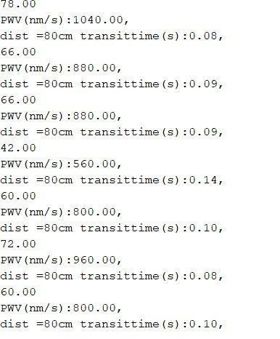­­­­

Table for ECG results

|  |  |
| --- | --- |
|  |  |
|  |  |

Combined code ECG and PPG

snippet

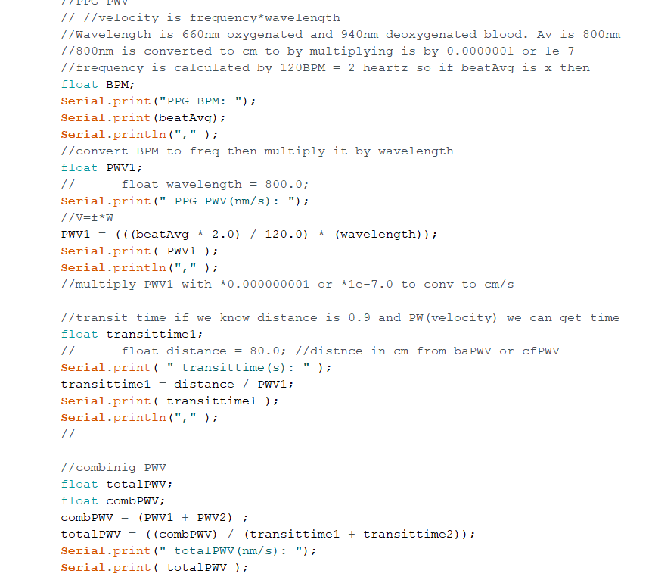

Basically adding the two PWV and dividing it by transit time

The QRS wave(ECG)

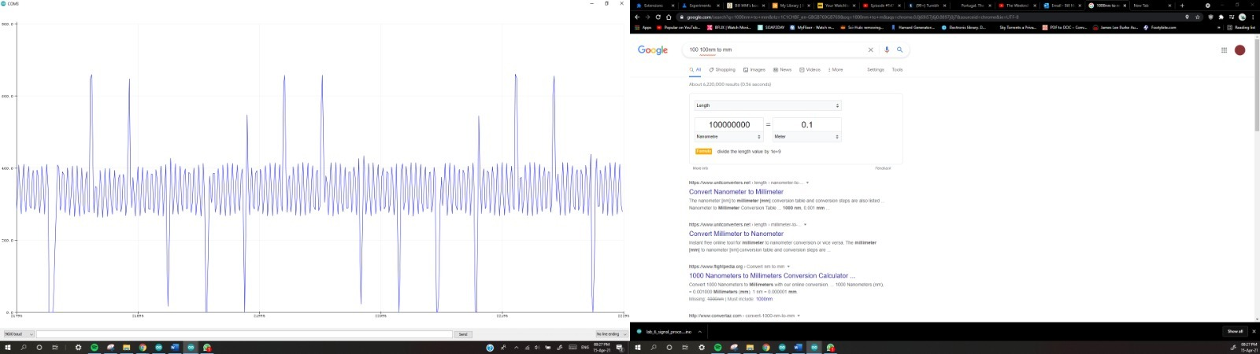

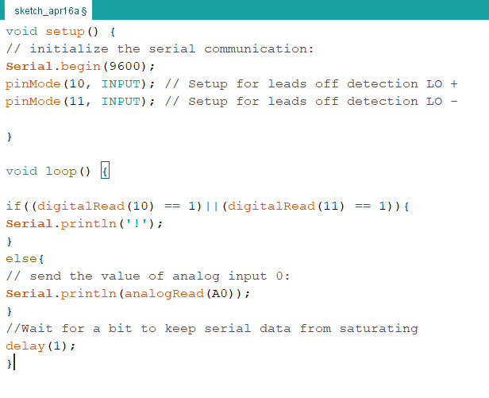

QRS (PPG)

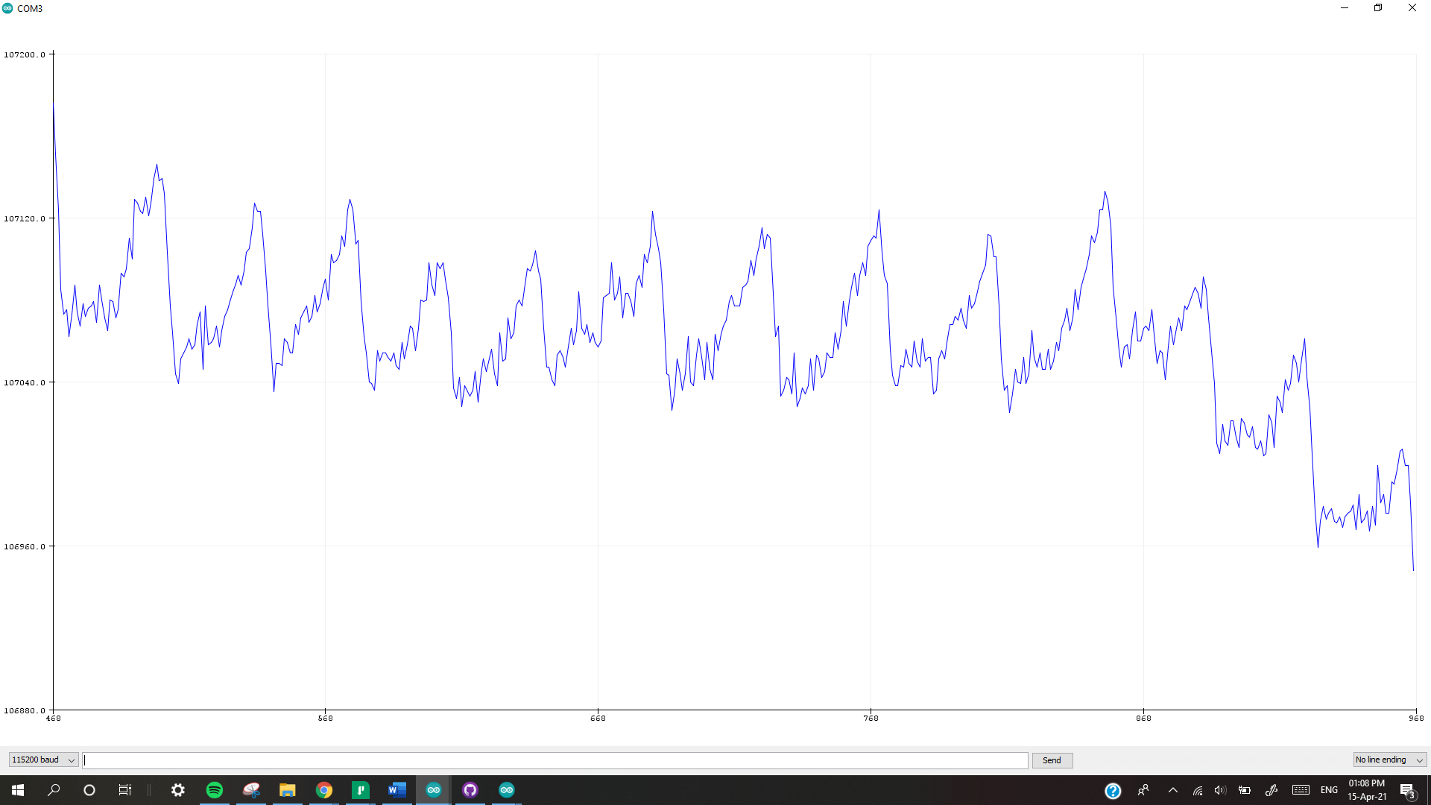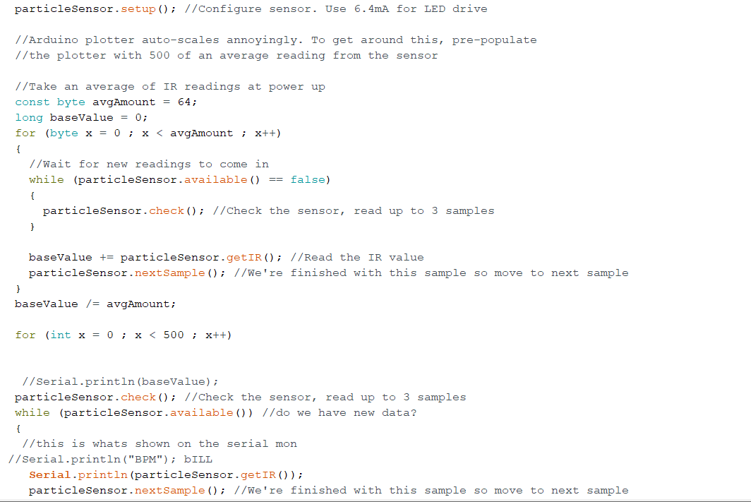

Protocol followed.

Foot position for ECG

Foot position

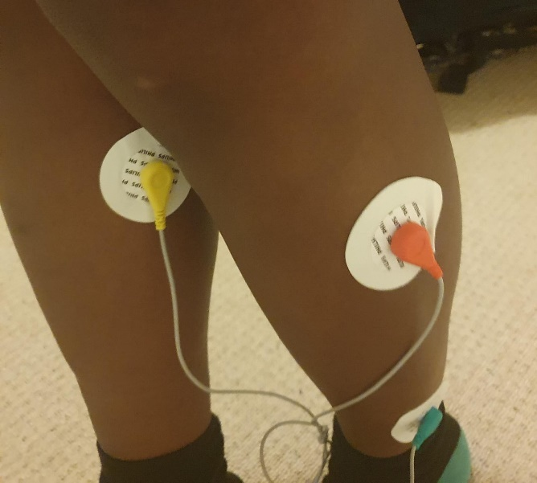

PPG sensor

Tape over sensor to reduce light.

